Github link :- https://github.com/Princekush566/tudedude.git

Part 1: Deploy Both Flask and Express on a Single EC2 Instance
- Objective: Deploy both the Flask backend and the Express frontend on a single EC2 instance using Terraform.
  - Provision the EC2 instance with Terraform.
  - Configure the instance with:
    - A user data script or a configuration management tool (e.g., Ansible or Cloud-Init) to install dependencies (Python, Node.js).
    - Scripts to start the Flask backend and the Express frontend.
  - Ensure both applications are running on different ports (e.g., Flask on port 5000 and Express on port 3000).
- Expected Deliverables:
  - Terraform configuration files (main.tf, variables.tf, etc.).
  - A working EC2 instance with Flask and Express running and accessible via the instance's public IP.
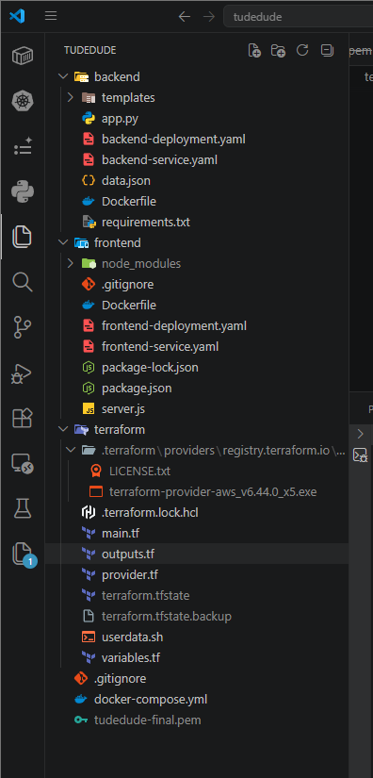

Main.tf
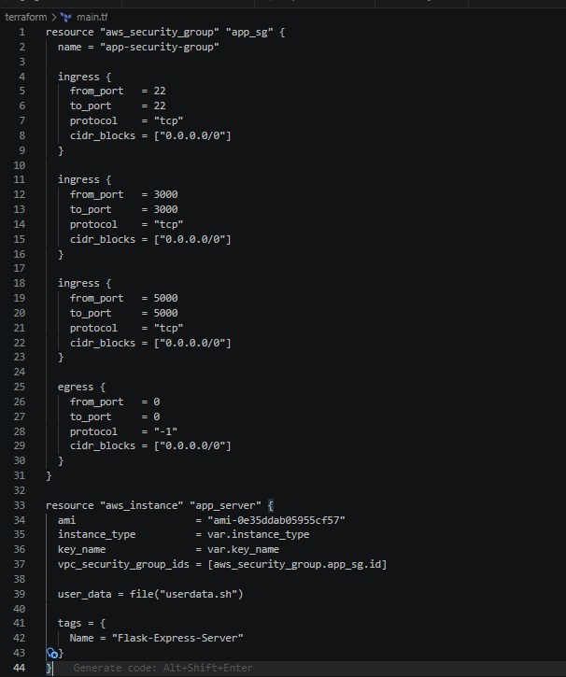

Output.tf
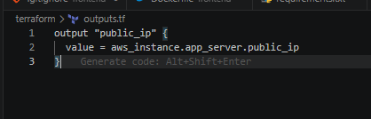

Provider.tf
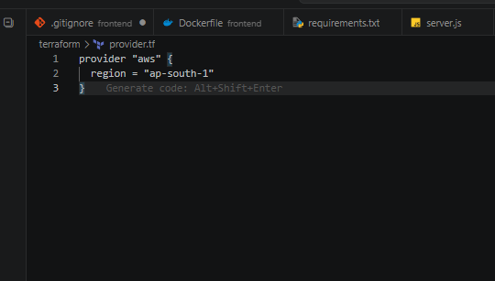
Variable.tf
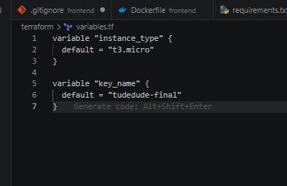
Userdata.sh
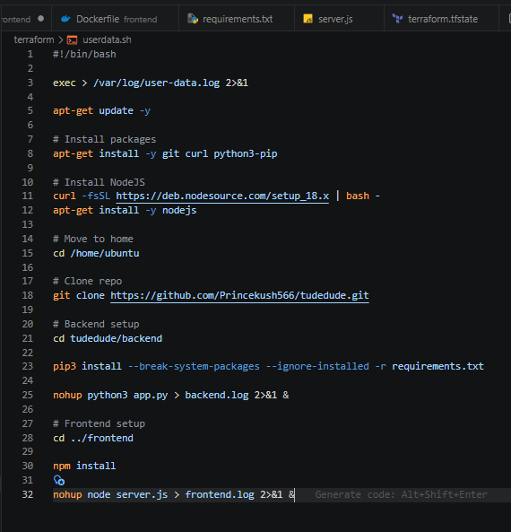
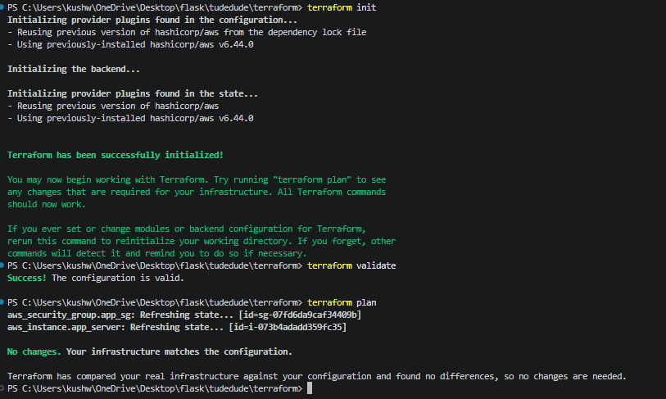
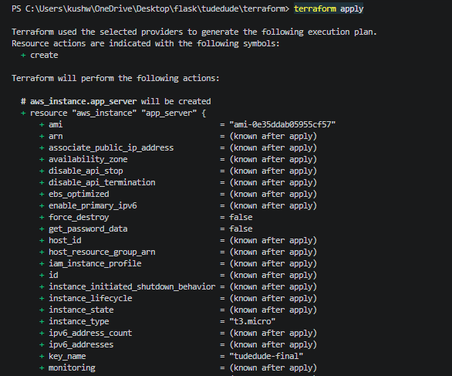

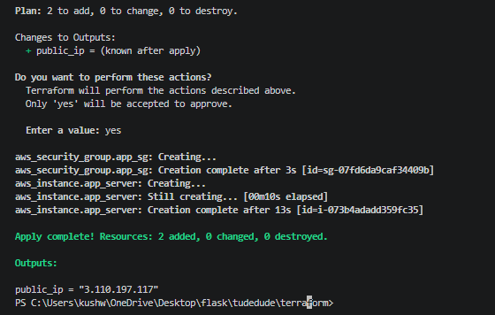

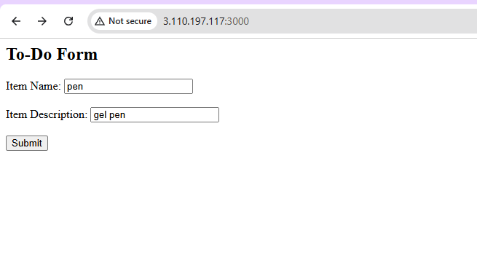
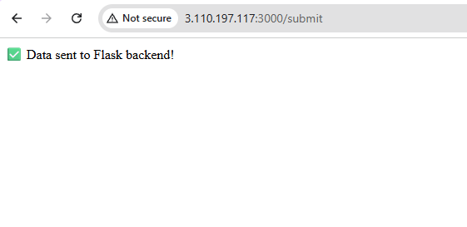
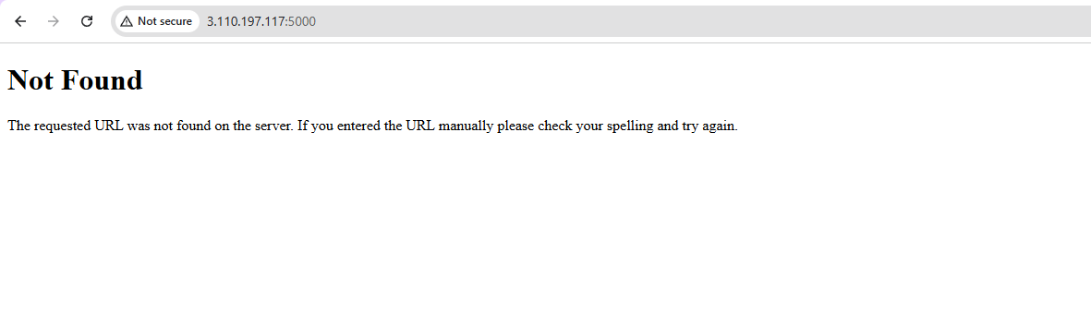
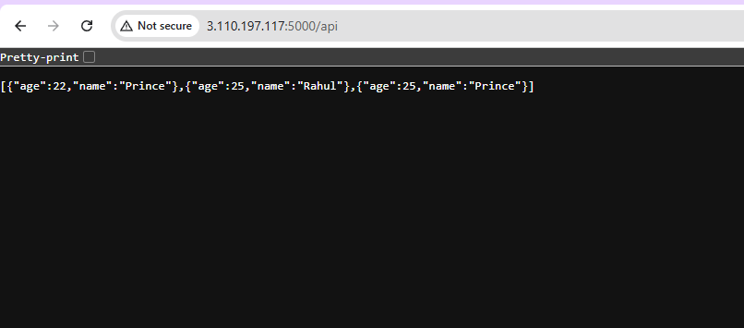
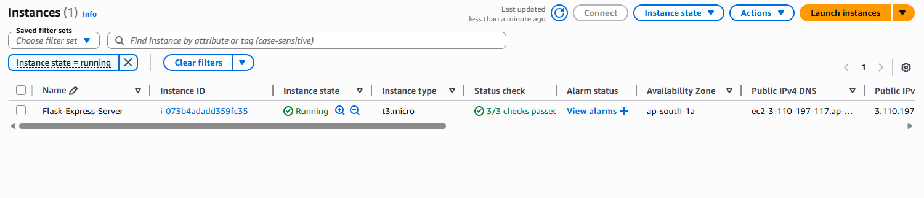
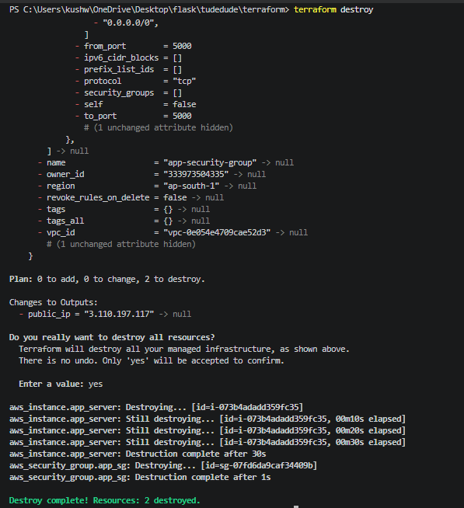
Part 2: Deploy Flask and Express on Separate EC2 Instances
- Objective: Deploy the Flask backend and the Express frontend on two separate EC2 instances using Terraform.
  - Provision two EC2 instances using Terraform:
    - One for the Flask backend.
    - One for the Express frontend.
  - Configure security groups to:
    - Allow communication between the two instances.
    - Expose both applications to the internet on their respective ports.
- Configuration:
  - Use Terraform to define networking resources, such as VPC, subnets, and security groups.
  - Use user data scripts to automate the installation and startup of both applications.
- Expected Deliverables:
  - Terraform configuration files.
  - Two working EC2 instances: one running Flask and one running Express.
  - Security groups configured to allow proper communication and public access.
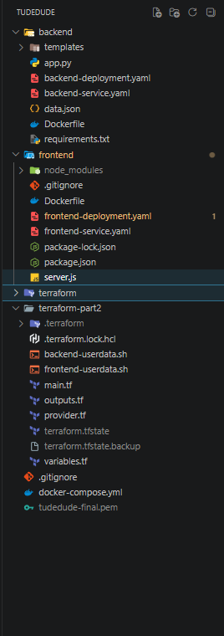
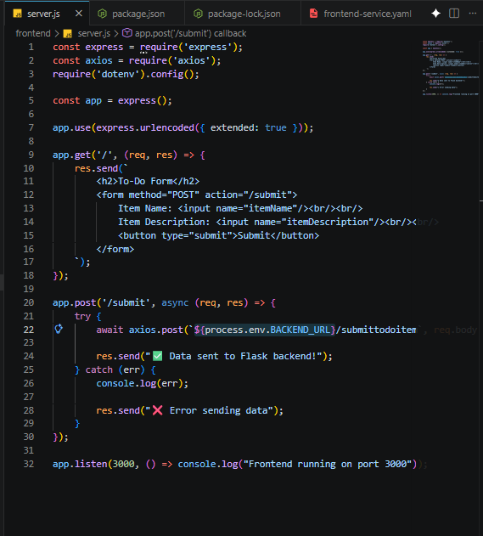

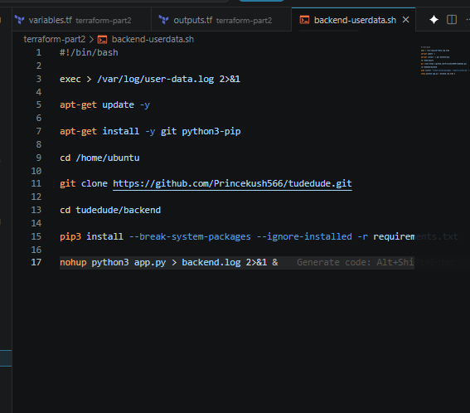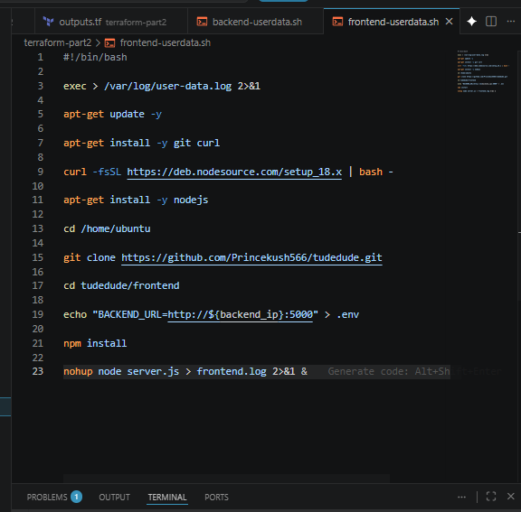
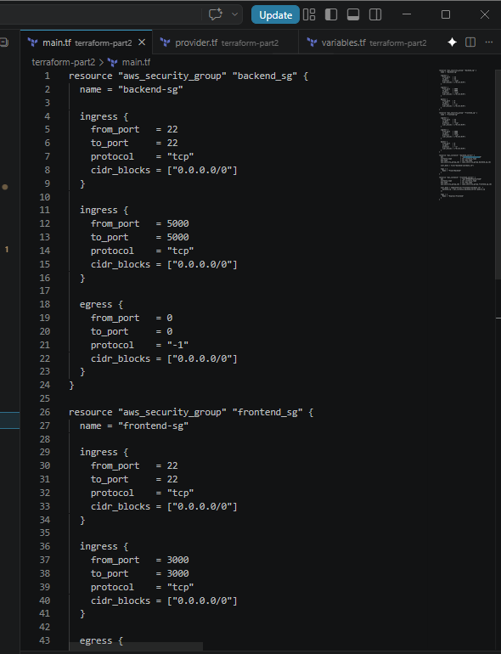
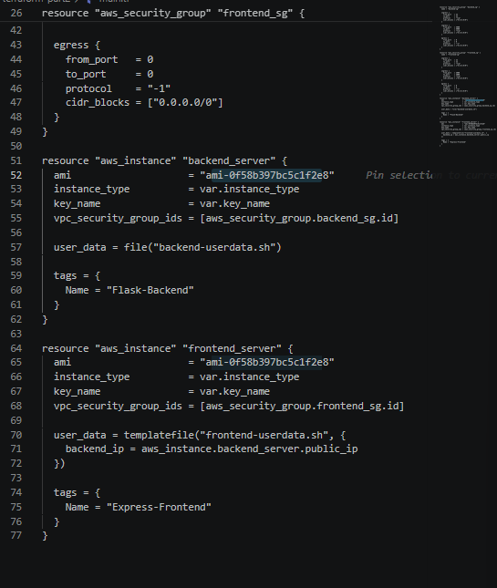
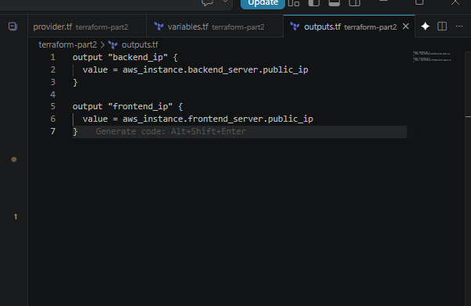
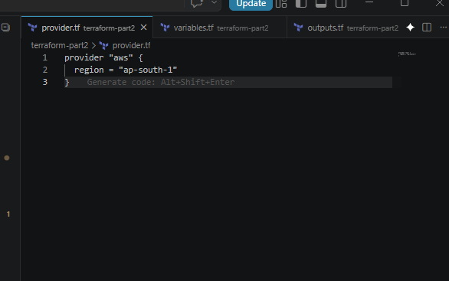
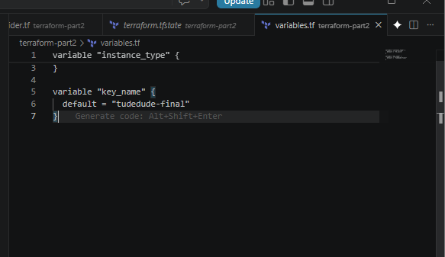
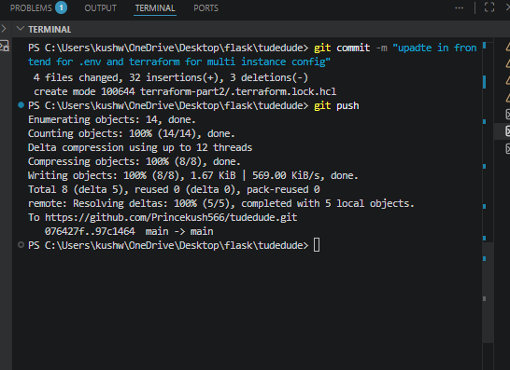
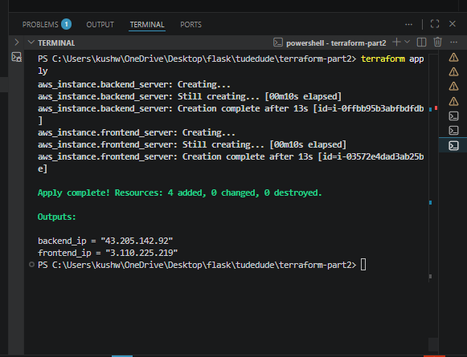
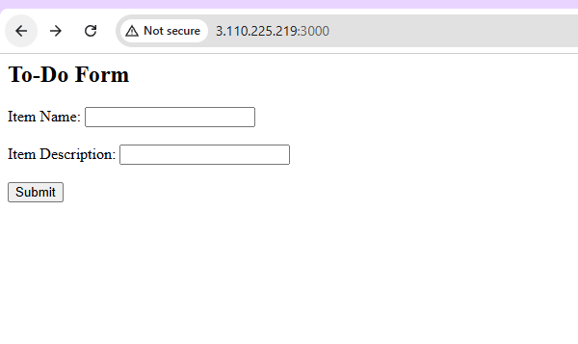
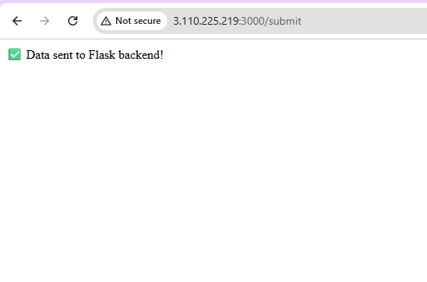
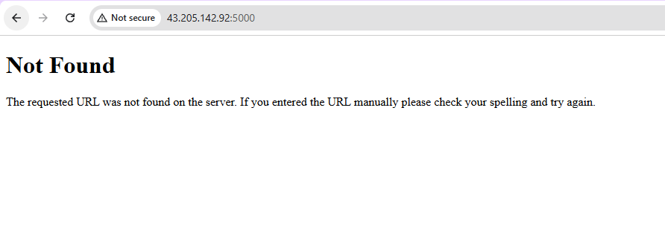
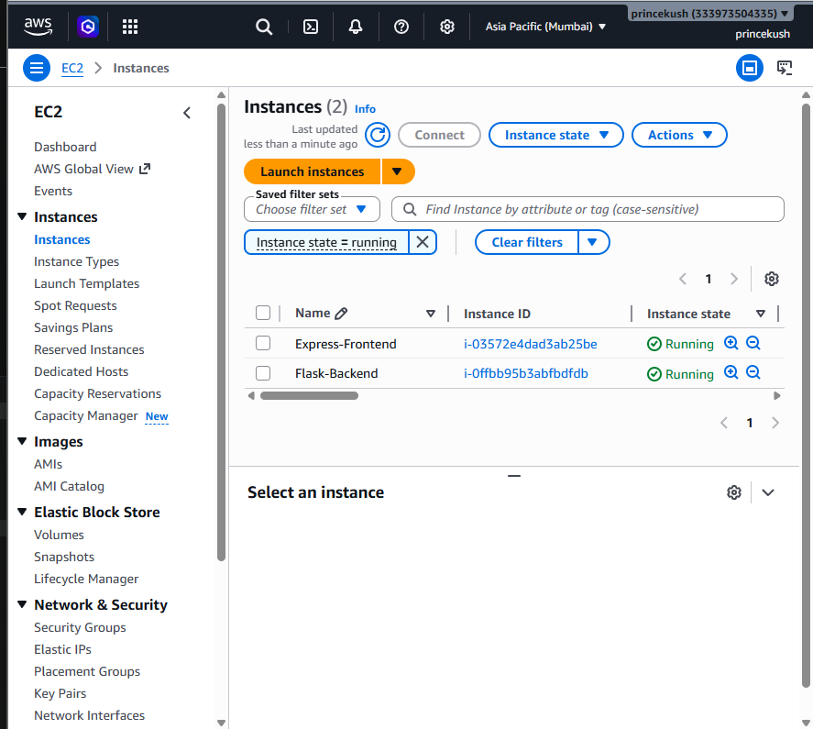

Part 3: Deploy Flask and Express Using Docker and AWS Services
- Objective: Deploy Flask and Express as Docker containers using AWS ECR, ECS, and VPC with Terraform.
- Steps:
  - ECR:
    - Use Terraform to create two Elastic Container Registry (ECR) repositories: one for the Flask backend and one for the Express frontend.
    - Build Docker images for both applications and push them to their respective ECR repositories.
  - VPC:
    - Use Terraform to create a VPC with subnets, route tables, and security groups.
  - ECS:
    - Use Terraform to set up an ECS cluster.
    - Create two ECS services:
      - One for the Flask backend.
      - One for the Express frontend.
    - Use ECS Fargate or EC2 launch type to deploy the containers.
  - Load Balancer:
    - Use Terraform to provision an Application Load Balancer (ALB).
    - Configure ALB listeners to route requests to the appropriate ECS service.
- Expected Deliverables:
  - Terraform configuration files for ECR, ECS, VPC, and ALB setup.
  - Docker images pushed to ECR.
  - ECS services running and accessible via the ALB.

